Quarterly Report – January-March 2026
Genetic diversity and seed quality of bull kelp (Nereocystis luetkeana) cultivated from gametophytes and conventional methods

Lead Entity: Dr. Angela Korabik
Grant: RFP #2024-06 Kelp Seed Quality Improvement

Project Location: Cordova and Kodiak

Project Start Date: June 1, 2025

Expected End Date: September 30, 2026

Award Amount: $198,977.82

PROJECT OVERVIEW

With this project, we aim to answer many of the existing questions about alternative seeding methods, effective population size, and local genetic diversity by testing three methods of kelp seeding. We will determine how the seeding method affects the genetic diversity, spool quality, and harvest quality in bull kelp, a species of interest in the Alaska kelp mariculture industry. These methodologies would likely work to support genetic diversity for other commercially grown kelp species given similar modes of reproduction and hatchery techniques used. This project will answer questions of high importance in the policy and regulation of mariculture operations and genetics and test the feasibility of using different seeding methods in hatcheries located in two mariculture regions of interest in Alaska, Kodiak and Cordova.
This project addresses three primary aims regarding kelp genetic diversity as it relates to mariculture in Alaska:
- Compare genetic diversity of kelp seeded from conventional spore inoculation and controlled and uncontrolled gametophyte culture. Here, we define “controlled parental contribution” as a solution containing equal proportions of gametophytes from each parent sporophyte, and “uncontrolled parental contribution” as a solution containing an undetermined proportion of gametophytes from each parent. We hypothesize that spools seeded from gametophyte cultures of controlled parental contribution will have greater genetic diversity and better reflect the genetic diversity of the original parent population used for culture.
- Compare the quality of kelp development in gametophyte versus sporophyte-seeded cultures. We hypothesize that gametophyte-seeded cultures will result in better spool coverage and seed quality than spool seeded spores, due to our increased control of density.
- Compare the parental contribution of parents from Kodiak kelp populations to Cordova. We hypothesize that parental contribution to offspring genetic diversity will be greater in Kodiak than Cordova due to Kodiak’s more exposed location and larger kelp beds.

COMPLETED TASKS

Task 1: Collection and hatchery
- PWSSC collected bull kelp tissue for genetic analysis and seed production from 60 parents in Kodiak, AK and 60 parents in Cordova, AK at two different seasonal time periods (end of summer and mid-autumn).
- PWSSC used sori to produce two types of gametophyte cultures: single parent cultures and gametophyte cultures with uncontrolled parental contribution. These two gametophyte solutions will both be used to seed spools.
- PWSSC used collected sori to seed spools with traditional, spore-seeding methods.
- PWSSC has cared for seed spools in accordance with best operating practices for kelp hatcheries, checking spools regularly during the hatchery period, and taking photos to track seed spool quality.
- PWSSC has collected tissue from spools (KOD – all treatments, CDV – uncontrolled parent cultures) for genetic analysis when more than 50 sporophytes on the spool have reached a length of 2mm.

Task 2: Outplanting
- Alaska Ocean Farms outplanted the Kodiak kelp on February 17, 2026.

Task 3: Genetic Analysis
- PWSSC has coordinated transportation of genetic samples for parent tissue during sorus collection from Alaska to the University of Wisconsin, Milwaukee.
- Samples have been processed to extract DNA.
- DNA was extracted and QC’d from 50 out of 60 parents per site (Kodiak, Cordova)
- PCR amplification was successfully verified for 12 parents per site (Kodiak, Cordova) with one microsatellite marker, Nl24

DNA was extracted from all parental samples (60 August–Cordova, 60 August–Kodiak, and 50 November–Kodiak), quality-checked, and amplified using a panel of 8 microsatellite markers (Nl24, Nl25, Nl26, Nl27, Nl40, Nl47, Nl50, Nl59). The resulting products were sequenced and scored in STRand fragment analysis software for downstream analysis.

Two progeny plates were also successfully amplified using PhireTaq PCR with the same set of 8 microsatellite markers. An additional 3 plates have been received at the University of Wisconsin–Milwaukee and are ready for continued amplification.
Task 4: Deliverables
- We delivered the progress report detailing project updates for AMC in January 2026.

ONGOING TASKS

Task 1: Collection and hatchery
- PWSSC is currently analyzing photos and data from the hatchery portion of the experiment to determine how seeding method affects spool quality.

Task 2: Outplanting
- Kelp is currently growing on Alaska Ocean Farms site, and we are planning to harvest in late May/early June.

Task 3: Genetic Analysis
- Samples are being processed to extract DNA.
- DNA extraction will be repeated to include remaining parents from both sites and to address contamination observed during extraction, as well as including samples received at the University of Wisconsin, Milwaukee in early January
- PCR will be performed on all samples with a total of 8 markers, and prepared for fragment size analysis

PhireTaq PCRs will next be performed on the 3 remaining progeny plates using the same panel of 8 microsatellite markers.

Task 4: Deliverables
- This is the second progress report detailing project updates for AMC.

UPDATED TIMELINE AND TASKS
Blue boxes denote the original proposed timeline. B= Task Began, C = Task Complete, I = Task In Progress, NYS = Not yet started.
May 25 | Jun 25 | Jul 25 | Aug 25 | Sep  25 | Oct 25 | Nov 25 | Dec 25 | Jan 26 | Feb 26 | Mar 26 | Apr 26 | May 26 | Jun 26 | Jul 26 | Aug 26 | Sep  26
Task 1: Supply and Hatchery Prep
 | B |  | C
Task 2: Collect parent sori and parent genetic material
 |  |  | C |  |  | C
Task 3: Send sporophyte tissue samples to UW Milwaukee
 |  |  |  | C |  |  | C
Task 4: Genetic Sequencing @ UW Milwaukee
 |  |  |  |  | B |  |  |  |  | I
Task 5: Gametophyte Culture
 |  |  | B |  |  |  | C
Task 6: Spool Seeding and Cultivation
 |  |  |  |  |  | B |  |  |  | C
Task 7: Collect spool quality data and spool genetic material
 |  |  |  |  |  |  |  |  |  | I
Task 8: Outplant kelp on farm
 |  |  |  |  |  |  |  |  | C
Task 9: Harvest and collect offspring genetic material
 |  |  |  |  |  |  |  |  |  | NYS
Task 10: Data analysis
 |  |  |  |  |  |  |  |  |  | NYS
Task 11: Submit Final Report to Alaska Mariculture Cluster
 |  |  |  |  |  |  |  |  |  | NYS

ADDITIONAL INFORMATION
In our last report, we described the loss of two of the six originally planned treatments, with the hope that the final four treatments would be successful. While the Kodiak spools did grow successfully in the hatchery trials, and were successfully outplanted in February, the Cordova spools continued to experience significant contamination challenges. Contamination completely overwhelmed gametophyte growth in January, and existing seedline on the spools had to be completely discarded. We reseeded the spools with remaining gametophytes at the beginning of February in order to restart the project. After reseeding, spools from the uncontrolled parent culture were able to successfully produce sporophytes, albeit at much lower density than would be suitable for outplanting. The controlled parent mix, on the other hand, continued to have contamination issues – this time a bacterial mat that seems to have prevented adequate gametophyte development. We still kept these spools under culture in the hopes that remaining gametophytes will develop sporophytes by the end of April, but with no success. Ultimately, we decided that overall the Cordova spools were not worth outplanting on the Wild Blue Mariculture Farm. Due to these repeated challenges and the need to shut down our hatchery system to prep for the commercial season, we chose not to restart any trials again.
Despite these challenges, we will still be able to answer the following questions:
- How do spore seeded lines compare to gametophyte seeded lines for Kodiak?
- How does parental contribution to offspring genetics change in the time between outplanting and harvest in Kodiak?
- How do the genetics of parent and uncontrolled gametophyte cultures vary between Kodiak and Cordova?
We are also requesting an extension to this project so that we can re-run trials this fall and thus more rigorously answer our original project questions, as well as new questions that have arisen during the course of this project.

FIGURES
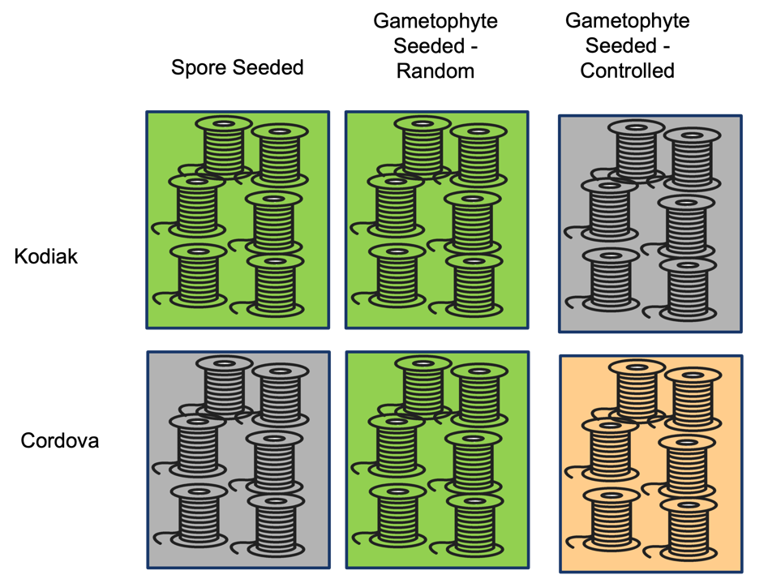
Figure 1. Revised treatment plan. Gray boxes have been excluded from the experiment while green boxes remain. Orange box represents the most recent treatment lost to contamination.

